HANDBOOK
FOR

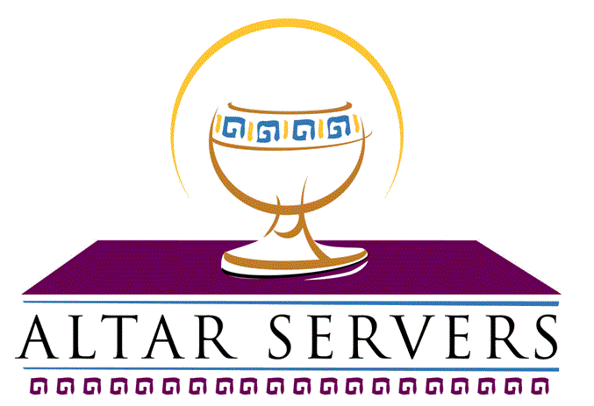

St. Matthew Church
Longview,
Texas

TABLE OF CONTENTS
I. Introduction
II. Server’s Prayer
III. General Information
Who is an Altar Server?
Who can be an Altar Server?
Dress Code
Schedules
Guidelines
Behaviors
IV. Order of Mass
V. Before Mass Begins
VI. Step by Step during the Mass
VII. Positions and Movements
VIII. Candles
IX. Thurible
X. Prayers Used During Mass

INTRODUCTION
The server is an important person.
Every priest needs a server’s help to celebrate the Holy Mass.
A server is the celebrant’s right hand helper.

This manual has a two-fold purpose:
Firstly, to train you to serve the Holy Mass, and
Secondly, to use as a reference whenever necessary.
As you will note, a server has much to do. Your training will not be complete until the manual has been mastered.

Servers have been with us a long time.
In the Bible: (1Sam. 2-3)
There was Samuel who lived over a thousand years before Christ.
His mother Hannah prayed for a son.
When he was born she consecrated her son, Samuel, to God;
and left him to serve the Lord.
Samuel was called by God.
He served in the Temple with a priest,
and anointed the first King of the Hebrew people.

Being a server is an important calling.
God is asking for special dedication and service from you.

This manual should help you to function well during the ceremonies and, ultimately, to come closer to God.

ALTAR SERVER'S PRAYER
Loving Father, Creator of the universe,
you call your people to worship,
to be with you and each other at Mass.
Help me, for you have called me also.
Keep me prayerful and alert.
Help me to help others in prayer.
Thank you for the trust you have placed in me.
Keep me true to that trust.
I make my prayer in Jesus' name,
who is with us in the Holy Spirit. Amen.
GENERAL INFORMATION
The following information applies to all active altar servers and those boys and girls who have expressed an interest in becoming altar servers.
Who is an Altar Server?
An altar server is a lay assistant to a member of the clergy during a Sacred Liturgy.
To be an altar server is a privilege and honor not to be taken lightly. Along with this privilege and honor comes the responsibility and commitment for both parents and students.
It is a great privilege to serve at the Altar of our God and, therefore, Servers are chosen from those who display a desire for a more intimate union with our Lord and God, Jesus Christ.
Our loving Savior becomes present on the Altar, just as He was at the Last Supper and Calvary. Accordingly, Servers have a solemn responsibility to do their assigned duties with dignity and reverence.
Altar Servers fulfill a very important ministry in Liturgy. Their service adds to the orderly and prayerful to the assembly.
Who can be an Altar Server?
- Baptized and received First confession and First Communion.
- A desire to serve at the Altar of Our Lord and Savior, Jesus Christ.
- Servers should be mature enough to understand their responsibilities and to carry them out well and with appropriate reverence.
- Willing to undergo training, formation and supervision.
- Committed to serve, schedule, promptness (ready to act quick)
- Able to know basic prayers and responses at Mass.
- Able to master all postures and gestures.
- They should have already made their first confession or received First Holy Communion and normally receive the Eucharist whenever they participate in the liturgy.
Dress Code:
Shoes or sandals – dress shoes (preferred) should be worn. No flip flops or flashy or lighting tennis shoes, please. For the girls no shoes with a heel of 1” or more.
Dress: Servers need to dress appropriately when you are serving; no shorts.
Hair – Hair should be neat and trimmed, appropriate for boys and girls. Girls should have their hair tied back so that it is not in their face. Safety with long hair and candles is always an issue. Should you forget, hair ties are usually available near the crosses, please feel free to take one and then keep it.
Jewelry: Do not wear anything that will make noise and/or will be distracting, or that will cause you to have problems serving. Girls may wear “appropriate” earrings to serve.

Schedules:
All altar servers will be assigned to serve the weekend Masses.
They will be scheduled for the Masses they choose to serve.
Servers will serve approximately once a month (Spanish Masses) or/ and at English Masses as and when needed.
Altar servers are also expected to sign-up for and serve other liturgies during the year, which consist of Holy Days, Christmas, Easter, funerals, weddings, including Stations of the Cross, and other special liturgies, which may take place at St. Matthew Church.
The weekend schedule will be published once a month. Servers will also be expected to serve at all Masses during school vacation times (Christmas season and summer vacation).
Guidelines:
For each Mass need minimum of three servers and maximum of five servers. For High Masses, we need minimum of 5 servers.
Servers should arrive to serve no later than 15 minutes before his or her scheduled Mass begins. If a server arrives late, but no less than 10 minutes before Mass, they may vest and serve their scheduled Mass.
If a server arrives too late (5 min. before the Mass) to serve, and non-scheduled server has volunteered to serve and is10 already vested, the scheduled server should note on the sign-in sheet that he or she was present but arrived late.
All servers must sign in on the sign-in sheet provided. This is the responsibility of the server. Signature must be legible.
It is also important that the substitute server sign in the correct space when serving for another server.
It is extremely important that a server obtain a substitute server when unable to serve their scheduled Mass.
THIS IS THE SERVER’S OBLIGATION!!! AFTER A SERVER HAS OBTAINED A SUBSTITUTE, IT IS NECESSARY FOR THE SERVER TO CALL OR EMAIL THE COORDINATORS AND REPORT THE DAY, TIME AND NAME OF THE SUBSTITUTE SERVER.
Upon arrival at church, all servers should check in the vestibule to see if a Mass has enough servers. If a Mass is short servers, please volunteer to serve. Even if late, you may vest and quietly walk-in to serve after Mass has started.
Remember, servers are part of the liturgy. Servers are to respond to the prayers and hymns along with the congregation.
Behaviors:
Altar servers are expected to conduct themselves in an appropriate manner. Servers are expected to be an example to others.
They should be listening, with hands folded properly (as taught in the training) at all times.
Inappropriate and unacceptable behavior will not be tolerated.
Talking during Mass will NOT be tolerated. It distracts the people in the church. You could be told to leave the altar and not return.
Once the Mass has started, servers are not to leave the altar. If you leave the altar for any reason (for example, blow your nose, get a drink, go to the bathroom, feel ill) do not return to your place until there is movement in the church during the Mass.
Cell phones should be turned off before vesting. At no time should an altar server have / use a cell phone while on the altar.
You are also expected to help clean up after Mass. It’s one of the best manners you show the other servers who come for next Mass (vestibules left in good order, robes hung up, etc.).
Thank you for this very special service of our Lord and your parish family.
ORDER OF MASS

Procession in:
Cross – The cross bearer leads the procession;
two servers with candles - two others (if available) follow
the candle bearers. Crucifix to the left side of the Altar;
candle bearers to the ambo or lectern and place the
candles on their stands on either side of the Ambo.
STAND: Sign of the Cross
Greeting
Penitential Rite: Lord Have Mercy
Gloria
Book bearer brings book up for Father
Opening Prayer
SIT: First Reading Responsorial Psalm Second Reading
STAND: Gospel
SIT: Homily
STAND: Profession of Faith Prayers of the Faithful
SIT: Collection
(Cross & Book Server: Place the book (Missal);
Two servers: Place the chalice, the Communion cups on the
altar); Two candle bearers go to receive the offertory gifts
from Priest;
Two servers: the wash bowl and towel to priest to wash
fingers.
STAND: Preface Dialogue
KNEEL: Holy, Holy; Eucharistic Prayer; Consecration; Memorial Acclamation; Doxology; Great Amen.
STAND: Our Father; Sign of Peace (Servers go to the priest and deacons to share the peace; then share peace with one another among yourself (Altar Servers).
Lamb of God; Response to invitation to Communion.
Book Servers: clear the book from the altar.
KNEEL: During Communion; a server brings water to Father when he comes back from Communion, if asked to wash his fingers.
STAND: Book brings Father the book; Final Blessing
PROCESSION OUT OF CHURCH:
After the deacon dismisses the congregation, the servers need to ready to take their respective objects (Crucifix and candles). The order of the procession is: the reversal of the Entrance procession. Cross bearer – two candle bearers – other servers – deacons and the priest.

Before Mass Begins
- The altar servers are responsible for ensuring that the candles in the sanctuary are lit. If they are not, please do so approximately 5-10 minutes before Mass begins.
- After the candles are lit, you can proceed together to pick up the candles and the processional cross.
    - If there is only one altar server, that person will carry the processional cross.
    - If there are only two altar servers, one will carry the cross, and the other will carry a candle in the procession immediately behind the cross bearer.
    - If there are three altar servers, one will carry the cross, and two will carry the candles slightly behind the cross bearer. Ideally, there should be symmetry in the procession.
- When you return to the back of the Church after picking up the processional cross and candle(s), meet in the foyer to pray with celebrant and other ministers.

Step-by-Step during the Mass
Entrance Procession
- When the people stand up for the opening hymn, move into the center aisle with the processional cross lined up with the last pew. When the people begin to sing, start moving forward at a slow, dignified, steady pace. When you reach the altar, pause for one second, and then move to place the processional cross and candle(s) in their stands and move to your assigned pew.
- The cross bearer stays on the left of the Altar to help with the book.
- Your job is to make sure that you don't visually distract the congregation; do everything gently, but at the same time, you need to sing, pray, and say the responses so that you can be heard.

The Mass Begins
- Once the Mass begins, you need to simply participate until the Liturgy of the Eucharist begins. The one obligation is that the "book bearer" needs to come forward for the opening prayer, at the end of Gloria.
- If the Gloria is sung, then "Let us pray" will happen immediately after it is over - so be ready. Go to the celebrant and he will hand you the open sacramentary (big red book). You will need to hold it at a position and an angle so that it can be easily read.
- How you hold book and where you need to stand will be determined by how tall you are. When the people say "Amen", you may return the sacramentary to the deacon, the acolyte, or place it on top of the book rack, and return to your seat – with other Altar servers, either to the right side of the Altar.
- If there are four servers there, the book & cross bearer could stay on the left of the Altar.
The Liturgy of the Word
- Altar servers are generally not responsible for anything during the Liturgy of the Word, except listening attentively to the proclamation of the Scriptures.
- The one exception is that for certain important liturgies (Christmas, Easter, High Masses) there may be a Gospel procession. For this, the candle bearers would accompany the priest or deacon from the altar to the ambo with the Book of the Gospels. IF this procession is ever used, you will be instructed at that time how it is to take place.
- The two candle bearers go up the ambo and hold the candles on either side while a deacon or a priest proclaims the Gospel.

Preparation of the Gifts
- After the General Intercessions, the people will be seated and the ushers will begin the collection.
- The cross bearer / book server should bring the sacramentary book to the altar.
- As soon as everyone sits, one altar server should bring the chalice and set it on the Altar.
- The other servers bring the trays with the communion cups and set up close to the edge of the right and left side of the altar (on the corporal) in an orderly way; and move the trays to the credence table.
- Then these altar servers should return to their seat.
- When the offertory procession begins, the priest or deacon will stand. This is your cue for servers (three servers) to join the priest in front of the altar. He will hand you either the ciborium with the hosts, or the flagon with the wine; and the collection basket.
- Leave the collection basket right in front and close to the Altar.
- The two servers take the ciboria and the flagon to the altar, but DO NOT set them on the altar. Wait for the priest of deacon to receive them.
- One of the servers brings the cruet with water to pour a drop in the chalice. Wait there to receive it back.
- When handling a cruet or flagon to someone, always hand it over with the handle pointed toward them. This makes it easier to ensure that the transfer takes place without the vessel being dropped.
- After offering the Bread and the wine, take the lavabo bowl and finger towel and stand near the table waiting for the priest to wash his hands. The signal to be ready to come forward is when the priest makes a long bow to the altar.
- If two altar servers are available, it is best for one to hold bowl and the other the towel. After this is accomplished, return the bowl and the towel to the credence table and return to your seats.

Eucharistic Prayer
- During the Eucharistic Prayer, kneel along with the congregation. One altar server should ring the bell when the priest lays his open hands on the chalice and ciborium; and he elevates the Host and Chalice. The bell should be rung three times with a quick twist of the wrist.

Offering Peace:
- When the priest / deacon announces, “let us offer each other the sign of peace”, the Servers come up to the priest and deacons to receive peace; then offer to one another.

Communion
- Altar servers do not have any specific responsibilities during the communion rite. However, be alert as there may be an occasion when the priest needs you to retrieve or do something.
- To receive Communion line-up with the Extraordinary Ministers of the Holy Communion; and after receiving Holy Communion form the priest, return to your pew.
- After communion is over, the Eucharistic ministers return the communion cups and ciborium, and bow before the Altar and return to their seats, be ready to bring the water cruet to the altar and hand it to the deacon or the priest.
- The two servers should have time to return with the tray after the vessels have been purified, and take them back to the credence table.

Dismissal
- As soon as the priest or deacon says the dismissal - "The Mass is ended, go in peace" or "Go in peace to love and serve the Lord" - then take the cross and the candles and stand in line with the first pew facing the altar.
- Remain there until the priest and deacon genuflect and turn around. At this point you should turn and lead the procession to the back of the Church.
- When you reach the place between the vestibules close to the big Crucifix, turnaround facing the altar so that the priest may reverence the cross.

Clean Up
- Blow out candles carefully.
- Return the processional cross and candles to their places by the altar. (if there is no next Mass).
- Then you can return to the closet and remove your cassock and surplice. Please make sure that they remain on the hangers.
- If you see anything that has fallen to the ground, please put it back on a hanger. After everything has been hung up, please close the closet door before you leave the Church.

POSITIONS AND MOVEMENTS
“Gesture and posture of priest, deacon, acolytes, and people, ought to contribute to making the entire celebration resplendent with beauty and noble simplicity, so that the true and full meaning of all parts of the celebration is evident...attention should be paid (to the details) and traditional practice of the Roman Rite, and to what serves the common spiritual good of the people of God, rather than private inclination or arbitrary Choice.” (Girm 42).
1. STANDING
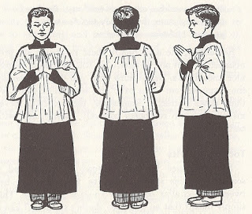
The altar server at the left has the proper standing position: head straight, body relaxed but erect, shoulders back, feet together, hands folded finger-to-finger (thumbs should be crossed) and pointing out from the chest. Hands are always to be kept in this position, even when walking. When you walk, walk slowly, dignified and deliberately. Know where you are going and then walk there with your head straight, shoulders back, hands held properly, and slowly. The server who does not have the proper position and walk becomes a distraction on the altar. Practice the correct postures at home in front of a mirror.
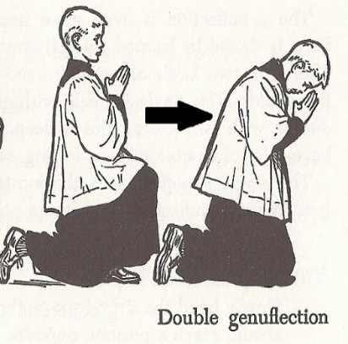
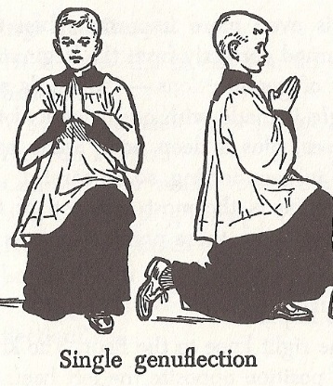
2. GENUFLECTING

In genuflecting on one knee:
a. Stand tall and keep your hands folded and in front of your chest
b. Slowly bend the right knee to the front keeping it next to your left heel. Make sure your back is straight.
c. After your knee touches the floor, rise slowly, and straighten up.
Do not be leaning over, or wobble. Make the action smooth and even.
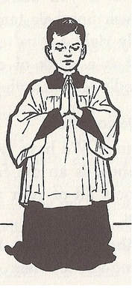
In genuflecting on both knees (in front of the exposed Eucharist):
a. Follow the same procedures as given for one knee, except that after your right knee touches the floor; bend the left knee next to it. b. Make a shoulder bow.
c. Then rise slowly bringing your left first, then rise straight up.
Make the action smooth and deliberate. Practice at home a number of times.

3. SIGN OF THE CROSS
To do it properly, unfold your hands from their folded position at your chest, placing the left hand on your chest. Keeping the right hand fingers closely together and fully extended, thumb in palm, trace the sign in a broad and full movement. Do not bring your right hand below the left, and be sure you touch the end of each shoulder. Then reclasp your hands.
4. GOSEPL SIGN
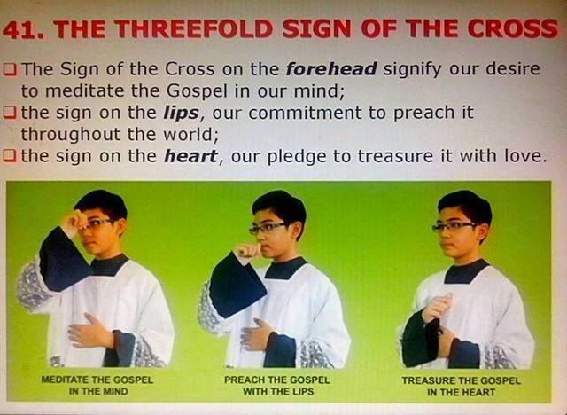
The primary use for this is immediately before the reading of The Gospel during the Mass. Using the right thumb, a small cross is traced over the forehead, lips, and heart of the individual while whispering or silently praying the words "May Christ's words be on my mind, on my lips, and in my heart."

5. SITTING
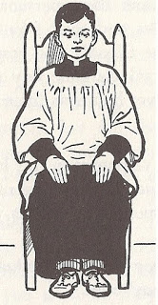
No slouching, leaning, lounging, crossing legs, and ankles;
No swinging of legs when sitting, or arms when walking;
Keep shoulder back, head up, back straight in a respectful and prayerful posture. Hand should rest on each knee when sitting.

6. WALKING IN THE SANCTUARY
Never walk too quickly during the Mass or other church functions. The sacred rites and actions have a particular speed, which must be learned. Never run in the church for anything.
Walk with hand clasped and not hands in your pocket or tied at your back. Walk with respect and reverence.
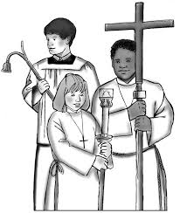
7. CANDLE:
Candle Lighting Procedure Light the candles ten minutes before Mass begins. First genuflect in front of the tabernacle and light those candles which flank the tabernacle, extending the rod if necessary. If you are having trouble lighting these candles, you must ask a Sacristan for help. Next, light the candles on each side of the altar, lighting those closest to the congregation first.
Finally, light the two candles on each side of the pulpit. Genuflect when passing the tabernacle and replace the candle extinguisher.
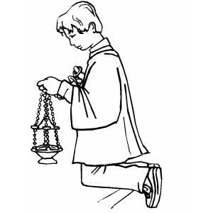
8. TURUFER & INCENSE BOAT:
The smoke of burning incense is interpreted Catholic churches as a symbol of the prayer of the faithful rising to heaven. This symbolism is seen in Psalm 141 (140), verse 2: "Let my prayer be directed as incense in thy sight: the lifting up of my hands, as evening sacrifice." Rev 8:3.

Incense may be used if desired in any form of Mass:
- During the Entrance procession, the server with Thurible (Thurifer) precedes the servers in the procession to the sanctuary. Another server carries the boat with incense and walks with the server with thurible.
- At the beginning of Mass, to incense the cross and the altar;
- When the celebrant ascends to the Altar, the thurifer and the server with the boat ascend to the altar on the ambo side.
- If the deacon is present, he receives it and pass thrurible to the celebrant.
- After the celebrant incenses the Altar, the server receives it from the deacon or priest
- At the Gospel procession and the proclamation of the Gospel itself:
- Just after the 2nd reading, the thurifer and the server with boat comes to the celebrant.
- Once the incense is put in the fire (thurible) the thurifer and the server with incense boat lead the deacon, followed by the two candle bearers, to the ambo to proclaim the Gospel.
- After the deacon or priest proclaimed “A reading form the Holy Gospel according to …” the thurifer hands the thurible to the deacon or priest.
- After he incenses the Book of the Gospel, he gives back to the thurible to the thurufer.
- Offertory: After the bread and the wine is offered, the thurifer brings the thurible and the incense boat to the celebrant. Then the celebrate incenses the gifts placed upon the altar, the altar, the cross, as well as the priest and the people.
- Then the deacon or the thurifer (in the absence of the deacon) incenses the people – thrice to the middle, and thrice on each side.
- At the Consecration: (showing of the host and the chalice)
- The thurifer goes with server with incense boat in front of the sanctuary and kneels in the middle and incenses thrice when the Host & the Chalice is elevated for adoration.
- After making a bow, they both reverently returns to their place.
- Before and after an incensation, a profound bow is made to the person or object that is incensed, except for the incensation of the altar and the offerings for the Sacrifice of the Mass.
BOWING:
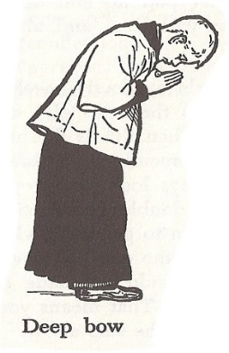
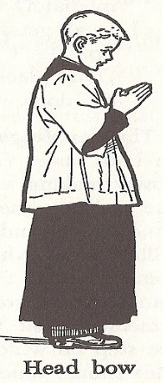
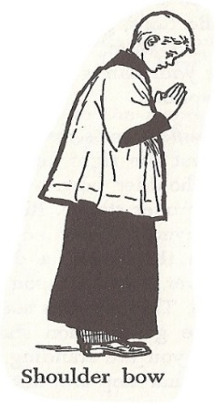

Bowing is a gesture of reverence. We recognize the altar as a symbol of Christ; Tabernacle as the presence of Christ; so we stop and bow to it whenever we pass in front of it.
The priest and all the ministers bow to the altar after processing to the sanctuary at the start of Mass. In the Creed, we bow at the words that commemorate the Incarnation: “by the power of the Holy Spirit he was born of the Virgin Mary and became man.”
We bow to the celebrant, after every service is done for him before you move away from the Altar.

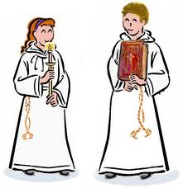
CARRYING THE BOOK & PROCESSIONAL CANDLE
Roman Missal: The book which contains all of the prayers said by the priest during Mass. This book is usually held by the Cross Bearer for the opening and closing prayers of the Mass. It is placed on the altar for the Liturgy of the Eucharist.

Special Liturgical Terms (to learn)
Liturgy: the official public worship of the Church
Celebrant: person who leads the ceremony liturgical ministers altar servers / choir / Eucharistic ministers
Paschal: the death and resurrection of Christ
holy water font: bowls that holds water at the doors /entrance.
Sacramental: something that reminds us of our faith (statue /
votive candle)
sacristy: room where Sacred Vessels are stored /prepared for the Mass
sacrarium The special sink used to cleanse sacred vessels that drains directly into the ground
chalice gold cup used by the priest to hold the wine
cruets the glass containers which hold the wine & water
paten Gold flat plate that holds the host
ciborium gold /silver cuplike container with a lid for holding the Body of Christ in the Tabernacle
finger bowl glass bowl used for washing the priests hands
corporal a square cloth which is placed on center of the Altar and on which the Paten, Chalice, and ciboria are placed
pacificator a cloth with cross in the corner or the middle used for wiping and purifying the chalice.
sanctuary area around the altar elevated structure for religious ceremonies
altar cloth table cloth for the main altar; always white celebrant's chair the central chair which is used by the celebrant during Mass
ambo The place from which the readings and psalm are proclaimed at Mass.
paschal candle: the large Easter candle, used at funerals and baptisms
ambry Area where the holy oils are stored; holy chrism - baptism, confirmation, and Holy Orders oil of the catechumen preparing those who want to join the Catholic Faith; oil of the sick holy oil that has been blessed by a bishop for use in the Anointing of the Sick
credence table: The small table on which is kept the things which are used during Mass.
Tabernacle the place in the church where the consecrated hosts are reserved
pyx The small container used to take communion to the sick.
sanctuary candle: candle that burns showing that Christ is present in the
Eucharist
Lectionary: the book which contains the scripture readings for the mass
sacramentary the Book from which the celebrant reads or sings the prayers for Mass
book of the Gospels: Large Book which contains the Sunday Gospel readings and is carried in the procession by the Deacon
vestment: items worn during the celebration of the Mass or administration of the Sacraments
amice (roman collar) short linen cloth that covers the shoulders
Alb The long white robe worn under other garments of liturgy
cincture A rope worn around the Alb to tie at the left side of the waist stole a scarf like colored cloth worn by an ordained priest (only thing necessary to perform
the sacraments)
chasuble A colored poncho-like vestment worn over the Alb
sign of the cross: reminds us of our baptism
entrance rite Approach of the celebrant and his assistants to Church worship
penitential rite In this prayer sinfulness is acknowledged and God's mercy is asked for lord have mercy
Gloria glory to god / a hymn of praise to God
opening prayer "to gather up"
first reading Comes from the Old Testament selection
responsorial psalm from the psalms, response of praise to readings and is usually sung
gospel acclamation We stand at this time, making the signs of the cross on our minds, lips, and hearts
gospel four books in the New Testament that tell the story of Christ's life and teachings
Homily sermon connects readings to Christian life
Nicene creed creed summarizing the Catholic Church's beliefs
prayer of the faithful prayer for the needs of anything good
prayer of petition prayer when we ask God for forgiveness
liturgy of the Eucharist the breaking of bread and sacrifice
offertory presentation of the gifts / when bread and wine is offered
thanksgiving meaning of the Eucharist
Eucharistic prayer the Church's greatest prayer of praise and thanksgiving, making present both the body and blood of Christ
preface Praises God the Father for His gifts of creation and redemption
transubstantiation the action during mass the bread and wine actually become the body and blood of Christ
memorial acclamation: we profess our belief in the passion, death. Resurrection, and glorious return of Jesus
Lord's prayer prayer given to us by Jesus (our father)
sign of peace handshake; symbolic of community
communion the act of participating in the celebration of the Eucharist
concluding rite farewell and blessing

The Four Parts of Mass
- Introductory Rite. **The Introductory Rites begin and introduce the Mass. ...
- The Liturgy of the Word. First Reading 2. ...
- The Liturgy of the Eucharist. Bring Forth of the Gifts 2. ...
- The Concluding Rite.
Processions at Mass are like mini journeys.
They lead us from one place to another. They always have a goal.
During Mass there are actually four processions, each with its own goal.

1. Entrance procession. This procession at the beginning of Mass is symbolic of the gathering of all the people into a unity for a common purpose of worship and transformation. The entrance procession symbolises our journey from being individual members of the Body of Christ to being the Body of Christ gathered around the one Head, Christ made visible in the church.

2. Gospel procession. The procession with the gospel book (usually from the altar to the ambo) is an opportunity for the assembly to acclaim the presence of Christ in the proclaimed word. It also is a symbolic expression of their journey from hearing God's word to putting it into practice. We are now invited to turn toward the gospel book and follow its journey to the place of proclamation as a sign of respect.

3 Procession with the gifts. The procession and presentation of the gifts symbolise the gift of ourselves presented to God for transformation into being more perfect members of the Body of Christ, just as the bread and wine are transformed into being the Real Presence of Christ. As the gifts are placed on the altar, we place ourselves on the altar and offer ourselves with Christ in sacrifice. It is symbolic of the ongoing journey of self-sacrifice that characterises Christian living.

4. Communion procession. The Communion procession symbolizes our journey to the messianic table, that heavenly banquet where we already share by partaking in Jesus' Body and Blood at Communion, and also which we will forever share when we die and go to heaven. This procession most clearly proclaims what it means when the Communion lines actually move forward toward the altar.
PRAYERS USED DURING THE MASS
Penitential Rite: I confess to almighty God, and to you, my brothers and sisters, that I have greatly sinned, in my thoughts and in my words, in what I have done and what I have failed to do; through my fault, through my fault, through my most grievous fault. Therefore, I ask Blessed Mary, every virgin, all the angels and saints, and you, my brothers and sisters, to pray for me to the Lord our God. Amen.
Gloria Glory to God in the highest, and on earth peace to people of good will. We praise you, we bless you, we adore you, we glorify you, we give you thanks for your great glory. Lord God, heavenly king, O God, almighty Father. Lord Jesus Christ, Only Begotten Son, Lord God, Lamb of God, Son of the Father, you take away the sin of the world, have mercy on us; you take away the sin of the world, receive our prayer; you are seated at the right hand of the Father, have mercy on us. For you alone are the Holy One, you alone are the Lord, you alone are the Most High, Jesus Christ, with the Holy Spirit, in the glory of God the Father. Amen.
Holy, Holy, Holy Lord God of hosts. Heaven and earth are full of your glory. Hosanna in the highest. Blessed is he who comes in the name of the Lord. Hosanna in the highest.
Lamb of God: Lamb of God, you take away the sins of the world, have mercy on us. Lamb of God, you take away the sins of the world, have mercy on us. Lamb of God, you take away the sins of the world, grant us peace.

